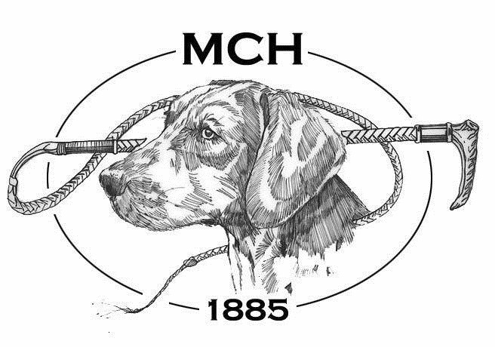
AGREEMENT FOR RELEASE AND WAIVER OF LIABILITY
I request permission to participate in cross-country riding and fox hunting with the Monmouth County Hunt.
I fully understand that cross-country horseback riding and fox hunting (which includes riding over fences, other obstacles and steep and rough terrain) are very dangerous activities. I wish to participate in these activities knowing they are dangerous. I accept and assume all the risks and injury (including death) to me or my property.
In exchange for being admitted to participate in these activities, for myself, my heirs, guardians, and legal representatives, I release and agree not to make or bring any claims of any kind against MCH or its masters, officers, directors, members, employees, guests, landowners, landholders or other persons making property available for MCH, for any injury (including death) to me or for any damage to my property, whether from negligence of MCH or anyone else’s negligence or any other cause, arising out of my participation in these dangerous horseback riding, foxhunting or related activities. I also agree if anyone makes any claim because of any injury to me (including death) or for any damage to my property, I will keep all those released by this agreement free from any damages or costs because of those claims.
Rider Name ________________________________________________________________
Signature __________________________________________________________________
Address ___________________________________________________________________
____________________________________________________________________
Phone ________________________________________ Date _____________________
Email Address ______________________________________________________________
I currently subscribe to another Hunt: __________________________________________
Social Media Release and Agreement

The Monmouth County Hunt uses photographs and videos of our members for a variety of projects and media. We have expanded our forms of communication to now include social media networks such as Facebook.
Because we are sensitive to the safety and privacy of the club as well as our members, at no time will images be shared without your consent as well as the consent of our Masters. Below is a release, which allows you to indicate your preferences.
Please indicate below whether the Monmouth County Hunt has permission to use photographs, images, or video of you.
Please check one:
☐ I agree that photographs, images and/or video of myself may be used for any publications, including those prepared for both an internal and external audience.
☐ I agree that photographs, images and/or video of myself may be used for any publications EXCEPT:
Facebook ☐ Instagram ☐ MCH Newsletter ☐External Publications (Covertside) ☐ NO, I do not want my photograph, image or video used in any way.
Members may post personal pictures of themselves.
Pictures of Monmouth County Hunt facilities, staff members, and hounds may only be posted with permission from a Master
Please submit any pictures or videos for approval that you would like to post to:
Diane Sigafoos, Honorary Secretary monmouthcountyhunt@gmail.com
☐ PLEASE CHECK HERE THAT YOU UNDERSTAND THIS POLICY
Name
____________________________________________________________________
Signature
____________________________________________________________________
Date
___________________________________________

